## Task - 01:

Define a class to represent a student. Include the following members

**Data Members**

* Name of the student
* ID number
* Department name
* Six Subjects
* Marks obtained
* Total marks

**Member Function**

* Write setter and getter property to set all attributes
* To calculate percentage and grade
* To display name and ID number, percentage and grade

## Task - 02:

Create a class **Teacher** with the following **private** attributes:

* Name
* Age
* Institute

Derive three classes from it that has the following names: **HumanitiesTeacher, ScienceTeacher, MathsTeacher**

These classes should have the following members:

* Field (this should have the value “science”, “maths” or “humanities”)
* Course Name
* Designation (for example, lecturer, professor, etc)

Create proper accessors and mutators for the attributes.

Create objects for each of the classes and display the values. You can ask the user to input the values

## Task - 03:

A defense organization is making an hierarchy of different types of weapons. They have classified the nuclear bomb as follows:

Weapons → Hot Weapons → Bombs → Nuclear Bombs

Create classes and apply inheritance as necessary for the above hierarchy.

Each class should have a method called: “xxxxxDescription”, where xxxx would be class name.

The method should print out what that weapon does. Eg. Hot weapons uses gunpowder, or explode. Bombs blow up. Nuclear bombs blow up, and use nuclear fission and fusion.

## Task - 04:

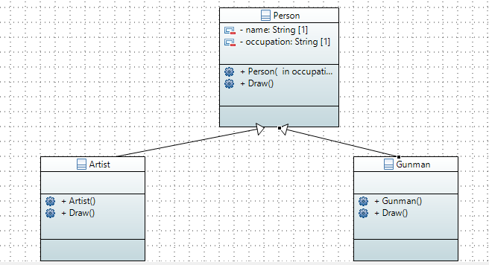

Create the classes following the diagram shown. Keep the following things in mind:

* When an object of Artist is created, the value “artist” will be set to occupation.
* When an object of Gunman is created, the value “gunman” will be set to occupation.
* Person::Draw() will print out “A person can draw in many ways”
* Artist::Draw() will print out “An artist can draw with a paint brush”
* Gunman::Draw() will print out “A gunman draws a gun to shoot”